**BI Assignment 3**

**Uzair Nadeem 24928 and Saad Thaplawala 27172**

**Dataset Information:**

**Name:** Superstore Dataset

**Link:** <https://www.kaggle.com/datasets/vivek468/superstore-dataset-final>

**Description:** The dataset has information about sales made by an online superstore that sells across different states of the USA. It sells products of three different categories: furniture, technology, and office supplies. The three primary metrics recorded are the sales amount, discount, and profit on an individual sale.

**Data Cleaning:**

The dataset was loaded into a python notebook and checked for incorrect datatypes and missing values. There were no missing values present. However, the Order Date and Ship Date columns for stored as strings. They were converted to into a datetime object, and new columns (Year. Quarter, Month, Day) were extracted from them in order to build date hierarchies in Power BI later.

**Power BI Report and Insights:**

**Pages:**

Title Page:

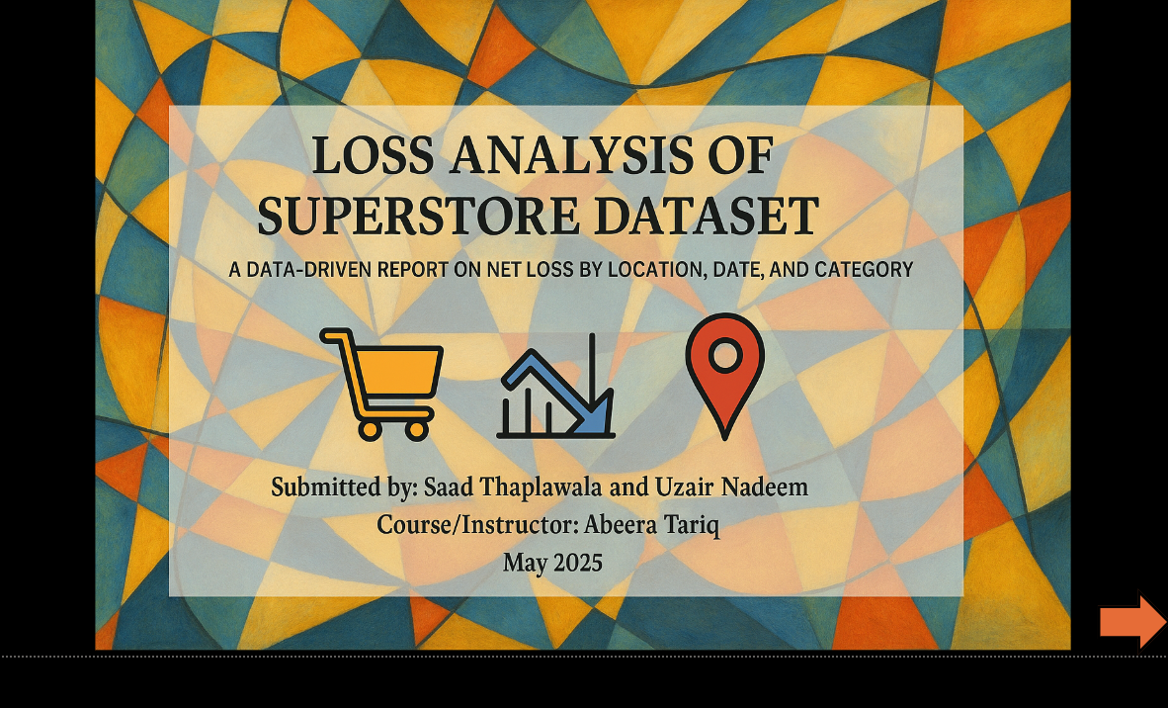

Problem Statement:

Overall Picture:

Location Analysis:

Product Analysis (Within low performing locations):

Analysis by Date (of low performing products within low performing locations):

Conclusions and Recommendations:

**Insights:**

Overall, net profit has seen an increasing trend from 2014 - 2017, but so does total loss, increasing to its peak in 2017.

The product category with the lowest net loss is Technology, and the category with the highest net loss is Furniture.

The west and east regions contribute to total loss, with east being the major contributor.

Texas, Ohio, Illinois, and Pennsylvania, are the top 4 loss generating states, and there are total of 10 states that incur a loss.

Most sales in the lower bracket contribute to losses. Further breakdown can be seen on coming pages.

Even though Texas has the highest loss overall, Illinois has the lowest percentage of profit margin( total profit to total sales).

Overall, technology products have a positive profit margin, while furniture and office supplies have a significantly high percentage on the negative side.

The bottom 5 sub-categories by total loss are binders, tables, machines, bookcases, and chairs.

For highly discounted products, the profit margin is mostly negative, which means discounts contribute to losses.

The products that have contributed the most to losses are Cubify CubeX 3D printers and GBC binding machines.

Binders have generated the highest loss across all years except 2016, with the highest loss incurred in 2017. While chairs have generated a loss in each year, it is significantly lower compared to other product sub-categories.

**Final Insights and Recommendations:**

* Discount should be capped at a value that allows us to break even, rather than incur a loss.
* Some states, especially Texas and Illinois have caused huge losses over the whole time frame with the product category causing the most issues being binders. The binders collection should either be evaluated to ensure product quality or be dropped from the inventory.
* 2017 is the year with the most overall profit but also the year with most loss, being around $53000, which is a greater number than the profit generated in 2015.